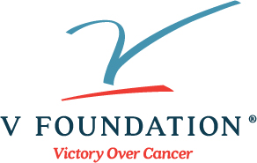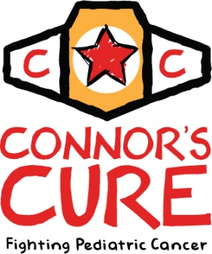

[Date]

Dear [Name],

Thank you for supporting my fundraising efforts for Connor’s Cure and the V Foundation for Cancer Research. Your generous gift will fund critical pediatric research at prominent cancer centers nationwide.

When Jim Valvano founded the V Foundation in 1993, he did so because he believed that one day we would declare Victory Over Cancer®. I believe that too. Together, we will find the cures for cancer that Jim always believed we would. Thank you for making a donation and for being part of something bigger than yourself.
"A person really doesn't become whole until he becomes part
of something that's bigger than himself."
—Coach Jim Valvano
I have raised [$amount] so far. Only [$amount] left to go until I reach my goal. Without your generosity, none of this would be possible. Thank you again for your support.

Sincerely,
[Your Name]

P.S. Please consider sharing my fundraising efforts with your friends and family and inviting them to support the V Foundation too. Just forward them this email and direct them to my personal fundraising page link at the bottom. Thank you!

14600 Weston Parkway, Cary, NC 27513 | 919-380-9505 | v.org

