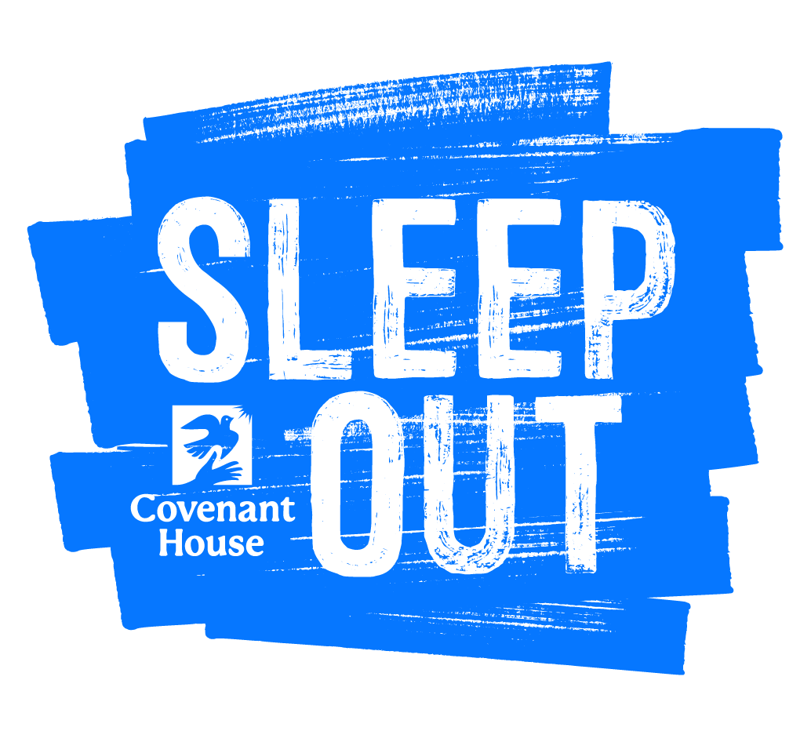

FOR IMMEDIATE RELEASE

Contact: [Your name]
[Phone, Email]

[Your Group Name] Sleep Outside in Support of Youth Facing Homelessness

On [Sleep Out date], [group name] from [your organization / town] will be spending the night away from the comfort of their homes, to raise awareness about and funds for youth facing homelessness.

This is the [#] annual Sleep Out [in town] planned by [your group] and [#] participants are expected to attend.

Sleep Out participants are not pretending to be homeless. Their night outside is an act of solidarity with the 4.2 million young people who experienced homelessness last year, recognizing the issue of youth homelessness and sending a message that everyone deserves a safe place to sleep.

About Sleep Out
Sleep Out is a growing movement to end youth homelessness and support the work of local Covenant House programs. Thousands of people across North America and around the world have joined together to Sleep Out and raise awareness about the youth homelessness crisis and funds to ensure that Covenant House’s doors can be open 24/7 for every young person seeking shelter.

About Covenant House
Covenant House is the largest provider of services to youth facing homelessness in North America. Covenant House, which has shelters throughout the U.S., Canada, Mexico and Central America, reaching nearly 80,000 young people each year.

General inquiries can be sent to sleepout@covenanthouse.org.

[Insert 1-2 participant or organizer quotes in the content above, where they make sense]

