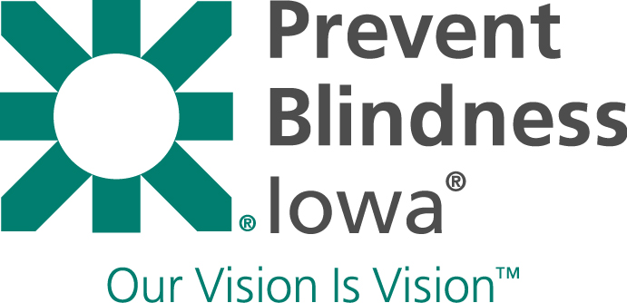
Meet Everett
2019 Youth Ambassador

Everett is a spunky 5 year old who can’t wait to be a kindergartener this fall. Not a day goes by that he isn’t building towers, drawing airplanes and daydreaming about becoming a garbage truck driver.

Last year, Everett took part in a free vision screening at his preschool conducted by Prevent Blindness Iowa. After not passing, he visited an eye doctor and was diagnosed with astigmatism and prescribed glasses. After finding the perfect pair, Everett has loved wearing them ever since.

“We are so thankful that Prevent Blindness Iowa’s screening was offered through his school,” stated Everett’s parents. “We were completely unaware that he wasn’t seeing things clearly and are so thankful to have caught it early.”

Everett loves putting on his glasses every morning. Not only do they look sharp, but they help him, in his words, “make things less fuzzy.” Thanks to the early detection of his vision problem, Everett will have two healthy eyes to spot garbage trucks from miles away!

Thank you for supporting Prevent Blindness Iowa and the Light the Night for Sight Walk! For more information,
please visit www.preventblindness.org/lnsiowa

