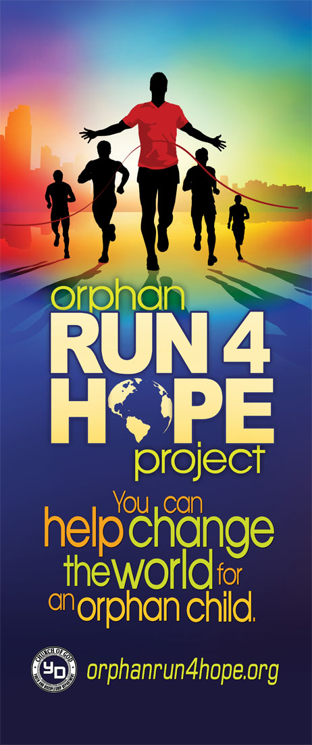

### **Fundraising Prizes**

### Each statewide race location will award trophies to the 1st and 2nd place winners in the following categories: children (12 & under); Youth 13-19; Church fundraisers (1st & 2nd place)

### The children & Youth winners are for speed. The church winners are based on amount raised.

### If a state has races in more than one location, a grand champion will be determined 60 days after the race based on amount raised.

Role of Church Point Person/Team Leader

1. SCHEDULE THE ORPHAN RUN 4 HOPE VIDEO to be played before or during your Church service to keep recruiting participants and to put a focus on the event. The video can also be sent via Facebook.
2. REGISTER RUNNERS by giving them access to the official JotForm link: <https://form.jotform.com/cogydmedia/or4h-registration>
3. EXPLORE TRAINING DAYS One option for Churches is to organize a group-training day. Your role is to set a day and time, once a week, where your team can meet and train together. While it will be hard to get everyone’s to sync…do the best you can. This helps the team build relationships with each other. The “Couch to 5K” Guide is available on our website.
4. PROVIDE A SPIRITUAL EMPAHSIS FOR YOUR TEAM This journey has the potential to bring true spiritual transformation if you seek it and structure for it by allowing the Holy Spirit to wok in and through your leadership. We encourage you to pray daily for your team and when you gather for group runs or meetings, start each meeting with prayer requests and prayer. In addition to this, you have access on our website to eight devotions to be used (one each week) while your team trains. These brief devotions only take a few minutes to read/share with your team.
5. CONSIDER MAKING YOUR CHARITY RUN AN OUTREACH OPPORTUNITY We would also like to encourage each team to invite co-workers or friends to participate in the race and group training days. If your team intentionally targets friends and co-workers that are not plugged into a church and may have never experienced forgiveness of sins through Jesus, this journey can be used to see people accept Jesus as their Savior.
6. ENCOURAGE FUNDRAISING GOALS Most people struggle or hesitate when it comes to asking people for money. In this case, remind your team that they are not asking for themselves. They are being commissioned by God to help provide for Orphan Children who desperate need help to have the basic necessities to survive. We usually encourage people to consider three levels: The 240 Challenge (feeds an orphan for a year), the 480 Challenge (feeds an orphan for two years), or the +1000 Challenge (feeds 4 orphans for a year). If your goal is $240, encourage your team is to break it down: “Do you know 12 people who would donate $20 to help provide food for an orphan child?” Your role is to encourage people every few weeks to reach or exceed their goal.
7. COMMUNICATE RACE DAY INFO As you prepare your team for Race Day, please remember to arrive at least 45-60 minutes before the start of the race. Also, know that most races are “rain or shine” events, which means the race usually takes place no matter what the weather is. Encourage your team to dress with the appropriate gear.
8. CHECK THE PROGRESS OF YOUR TEAM by logging into our website. Once you are registered as the team leader, you will have special access to your team’s fundraising progress.

# Orphan Run 4 Hope Information Packet for State Races

**Everything your State needs to accomplish a Charity Run that will make a difference in the lives of Orphan Children**

Orphan Run 4 Hope Project

P.O Box 2430, Cleveland, TN, 30320-2430

[mark@orphanrun4hope.org](mailto:mark@orphanrun4hope.org)

423.599.3210

Organization

Step 3: EACH CHURCH SHOULD PLAY THE VIDEO. Show the Orphan Run 4 Hope Promotional Video in your Church Service at least twice. Our video casts the vision for helping Orphans through this event.

Step 4: REGISTER RUNNERS. Continually Recruit Participants each week to SIGN UP! Participants simply register online by using the JotForm link: <https://form.jotform.us/81276325584159>

Step 5: UTILIZE OUR DIGITAL FUNDRAISING SYSTEM OR HARD COPY FUNDRAISING LETTER. We provide customizable, personal webpages to assist participants in their fundraising efforts. This webpage serves as a user-friendly, online donation site to help participants reach their goal. Runners will have access to a fundraising letter with an active fundraising link we have provided. If desired, the letter can be customized to add a picture of the participant. The best way to fundraise is by sharing the online fundraising letter through email, text, and Facebook messenger (people by name). The hard copy fundraising letter can be found on our website once the participant registers via the JotForm link. Then we email them their personal fundraising letter with an active link to their webpage.

* 240 Challenge – All participants are encouraged to set an individual goal of getting 12 sponsors that will each donate at least $20. The $240 can feed an Orphan Child for ONE FULL YEAR!!
* Digital Fundraising – is set up for each individual person based upon his or her name and email. It includes an active link to their personal fundraising page one they fill out the JotForm.
* The cost to participate is as follows and includes a FREE Orphan Run 4 Hope T-shirt and Medal:
* Adults and Teens $12 per person
* Children 12 and under $8 per child
* Shirt sizes – Adult: S, M, L, XL,XXL, 3XL Children: YS,YM, YL

**Resources available online:**

[**http://orphanrun4hope.org**](http://orphanrun4hope.org)

* **Social Media Kit**
  + **Facebook Logo**
  + **Instagram Logo**
  + **Promotional Video**
  + **Bulletin**
* **8 Devotions to encourage your team and use for outreach opportunities**
* **“Coach to 5K” guide**
* **Hard-copy Fundraising Letter**
* **Fundraising Tips**
* **Facts on the Need for Quality Orphanages**

**Some of our Counties of Impact:**

# **Things to Know**

**How Partnering with Orphan Run 4 Hope Benefits your Church:**

* It MOBILIZES your Church to support missions without drawing from your Church’s budget. Because it uses the relational strengths of co-workers, neighbors, friends, family, and local businesses, it does not take money from your church budget or missions budget. There are no offering or pledges taken at any time. All contributions come from outside of the Church and donations are done simply and electronically through a secure website which we have set up.
* It CREATES community while empowering participants to do something significant. Runners and non-runners alike will experience the motivational power of a cause greater than themselves. They will see first hand how they can impact the world for Christ in a significant way.
* It EMPOWERS your people to do something for Christ by tapping into their relational network. Each participant is encouraged toask for donationsform neighbors, family, friends, and co-workers. This approach uses the relational currency of the individual to bless orphan ministry. Every $20 raised is enough to provide food for a month for an orphan child at most of the orphanages in our network.
* It EXPOSES businesses and individuals to your Church, a worthy missions project & Jesus’ love. Charity Runs are a great community outreach tool to gain exposure for your Church. It highlights how your Church is engaged in a worthy cause. Participation is not limited to Church members. People from your Church can invite co-workers and friends to also run in the event, where they build relationships while training and running the race. Participants are exposed to Jesus’ love through your Church.
* It INCREASES Volunteerism through contagious, active people. The participants become a part of a team that train together and discover the joy of active participation. For many people who have never one a race, the process is a physical journey to get in better shape as well as a spiritual journey to accomplish something that they never thought they could.

**Five Simple Steps for Each Church:**

Step 1: YOUR STATE ADMINISTRATIVE BISHOP & STATE YOUTH DIRECTOR WILL SELECT THE DATE, TIME, AND LOCATION/S OF THE EVENT.

Step 2: EACH CHURCH SHOULD FIND A CHURCH POINT PERSON/TEAM LEADER. A church “Team Leader” serves as an encourager and organizer to champion this ministry project. The brochure and our website provides all the information needed to help you succeed in mobilizing and guiding participants.

# Getting Started:

Feel free to contact us with any questions you may have. We are here to encourage you as you lead your team to accomplish great things for God!

“If only 7% of the 2 billion Christians in the world would care for a single orphan in distress, there would effectively be no more orphans.”

- Stephen Curtis Chapman