Helpful Hints
- All walks as part of the 2023 Distance for Deliverance Walkathon will take place between June 9 – 18, 2023.
- Registration for the 2023 Distance for Deliverance Walkathon is free, with an emphasis on inviting others to register to walk or to donate in support of a walker.
- All participants will have an individual fundraising page they can customize and share.
- A route needs to be created for 2 miles. This route can be on local streets, sidewalks, laps around a track, on a local trail, or any other location that you can gain permission to use.
  - If a route is created, an image of the route map is recommended to be posted so participants have a sense of where they are walking ahead of time.
- Have distinct start and finish lines (it is often the same) near the starting area.
- Ensure there is ample parking available at the starting area for all participants to use, preferably free of charge. Indicate the parking location on the walk webpage if not at the starting location.
- Have the course clearly marked with cones, signs, or barriers to ensure that all participants stay on the mapped route.
- Ensure plenty of water is available for all participants and it is available at various points throughout the route with an encouraging volunteer handing it out as needed.
- Ensure there are available restrooms at the staging area before and after the walk.
- Have a first aid kit available for small medical issues.
- A registration table is needed to check walkers in and to enter new registrants.

Recommendations
- Have a table setup with Kairos promotional materials and volunteers to answer questions about Kairos. Not all participants will know about Kairos as they may have been invited to attend.
- Have an audio system at the staging area. It can play music, make announcements, introduce special guests, allow people to share their Kairos testimony, and get the walk started.
- Invite local leaders, pastors, politicians, or celebrities to attend and speak before the walk begins.
- Invite dogs to the walk. They can be a great draw for participants, and some may sponsor the dog to walk!
- Ask local businesses, churches, and organizations to consider a sponsorship. Whether it is monetary or in-kind support, the participation of the community is beneficial to spreading the word of our ministry. Offer them a space for a table or tent to promote their business.
- Promote the walk in your church bulletin, local community calendars, and to the local media to help spread the word.
- Reach out to local running or walking clubs to encourage participation. They may create a large fundraising team for the walk.

Walk Software Platform
- The Distance for Deliverance Walkathon will be using the DonorDrive online platform for event registration and fundraising.
  - Each walk coordinator will be granted access to DonorDrive and their walk.
  - A walk is requested to be setup by contacting KPMI at marketing@kpmi.org or by calling 407-629-4948. An event page will be setup with the general walk information and administrative access will be granted to the walk coordinator(s).
  - Those with administrative access can edit the messaging on the walk page, the default text for team and fundraiser pages, and customize and send emails from the already created templates.
  - All raised funds will be deposited into KPMI’s bank account and disbursed to your Advisory Council.
    - The Advisory Council Donor Coordinator will enter all donations into KairosDonor and Quickbooks. This event is a great way to build your donor database.
    - Facebook Fundraisers can be created and linked to a fundraiser’s DonorDrive, (the platform we will be using this year) individual fundraising page, so you can see all the funds you have raised in one place.
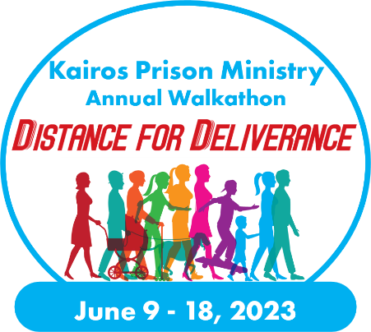
      - Facebook Fundraiser donations will go to KPMI and distributed out to the Advisory Council.

