Kairos Prison Ministry International, Inc.
“I was in prison and you visited me.” Matthew 25:36
Changing Hearts
Transforming Lives
Impacting the World
To get involved contact:
[Contact Person’s Name]
[Contact Person’s Email Address]
[Contact Person’s Phone Number]
January 24, 2023

KAIROS PRISON MINISTRY [OF STATE OR ADVISORY COUNCIL] IS JOINING THE DISTANCE FOR DELIVERANCE WALKATHON ON [ JUNE ##] IN [TOWN NAME]

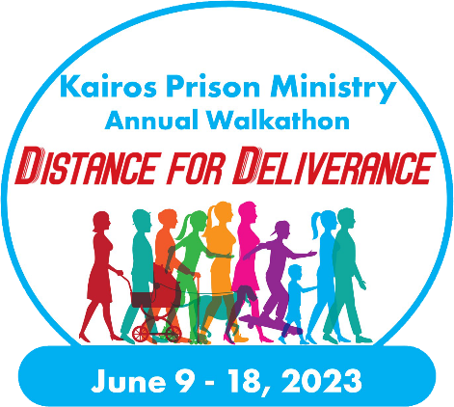
Greetings,
We are excited to share with you that Kairos [of State or Advisory Council] is hosting a Distance for Deliverance walk in support of those impacted by incarceration in our local community. Kairos is a Christian prison ministry that ministers in your community [at facility name or area] by working directly with [men, women, or youth] by [fill in information about how your Advisory Council serves the community]. Our walk will take place on [June/##/2023 at XXXXXX], and we would love for your church to be involved and come out and walk with us! Learn more about our ministry, its importance to [Town Name], and how your parishioners can get involved.

Additional information and registration links are available at [add your www.distancefordeliverance.org walk URL], and registration is FREE!

Kairos is a lay-led organization of 30,000 volunteers who share the transforming love and forgiveness of Jesus Christ to approximately 27,000 people annually who are impacted by incarceration. We serve incarcerated men, women, and youth as well as their families, to become loving and productive citizens of their communities. Kairos programs result in an improved prison living environment, reduced recidivism after leaving prison, safer communities, and healed families based on personal transformations.

To get your church involved with Kairos [of State or Advisory Council], contact [insert your preferred contact information and links to both your Distance for Deliverance walk registration and where they can learn more about Kairos].
Thank you for your consideration, and we look forward to seeing you and your parishioners at the Distance for Deliverance Walkathon and getting involved with Kairos [of State or Advisory Council].

[Signature]

About Kairos Prison Ministry
Kairos Prison Ministry International, Inc. is a lay-led, interdenominational Christian ministry in which men and women volunteers bring Christ's love and forgiveness to prisoners and their families through three programs: Kairos Inside, for incarcerated men and women; Kairos Outside, for female relatives/friends of the incarcerated; and Kairos Torch, for incarcerated youth. From simple beginnings as a short course in Christianity inside a Florida prison in 1976, Kairos has grown to serve more than 500 prisons and communities in 10 countries and 37 states. Each year more than 30,000 volunteers donate 3 million hours of service with an estimated dollar value of $36 million. To learn more, visit www.kairosprisonministry.org.

