Distance for Deliverance Donation Sheet
June [Date]
in support of Kairos [Advisory Council or State Name]
Name: _______________ Fundraising Goal: ____________
I am participating in the 2023 Distance for Deliverance Walkathon in support of Kairos Prison Ministry, an organization that is very close to my heart. We bring the love and forgiveness of Jesus Christ to those impacted by incarceration, both to the men, women, and youth who are incarcerated, but also to the women on the outside who have a loved one on the inside and are “serving time” alongside them.
I will be walking [#] miles and would love to have your support! Will you please sponsor me in making a tax-deductible donation to Kairos [Advisory Council]? I am asking for a donation of $ [##] which would really help me to reach my fundraising goal, or a donation of any amount, would be an incredible blessing.
Name of Donor | Amount | Cash | Check | Online
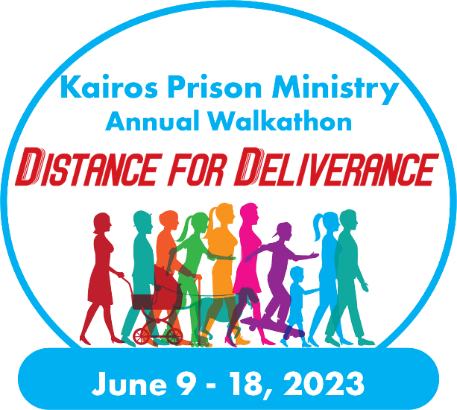
Totals
Please help me reach my goal of raising $ [###] for Kairos [Name of Advisory Council or State]. I can accept cash, checks made out to [Advisory Council Kairos of State], or you can donate at [URL]. Your donation is greatly appreciated and will be accompanied by a tax receipt.
Thank you for your support of this great ministry and for literally transforming the lives of those impacted by incarceration.

