You’ve got until the end of March to join us and become a CHANGE HERO in support of Baystate Children’s Hospital and collect spare change for the pediatric patients in your community! Whether you are an employee, an individual, a family, a school or a business, anyone and everyone can fill their Change Hero bank for the kids!
Website: www.helpmakemiracles.org/event/WMAS
Text to Donate: Text wmaskids to 51555

What is a “Change Hero”?
Registering to become a Change Hero is easy! All you need to do is collect pennies, nickels, dimes and quarters from family, friends and neighbors to help Baystate Children’s Hospital.
Meet Shane!

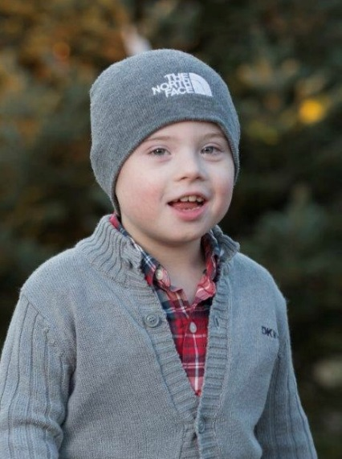
How will collecting spare change help Baystate Children’s Hospital?
Receiving care close to home can ease the emotional and financial burden on patients and their families by speeding up the healing process, decreasing stress and increasing access to the robust network of resources offered by world-class pediatric health experts. It can also lead to improved academic achievement for patients and their siblings and more days at school.
Why participate?
Funds raised will help support Baystate Children’s Hospital right here in Springfield for kids like Momo (pictured right) and many more. 100% of the money raised through the Change Hero Program will stay right here in your backyard in Springfield MA.
All of the change you collect stays local, supporting Baystate Children’s Hospital patients, like 9-year-old Shane of Chicopee.
Shane’s connection with Baystate Health began on October 27, 2009, the day he was born and diagnosed with Down syndrome. Nine years later, he’s our 2019 Children’s Miracle Network Hospital Champion, helping to lead the charge of supporting Baystate Children’s Hospital.
Join patients like Shane in making a difference for the kids!

How can I get started?
Register and ask for your coin boxes. Assemble the coin box and start collecting change! Share a story with family, friends and neighbors about why you think it’s important to collect change for Baystate Children’s Hospital. Please fill out the required information below.

*To register and request a Change Hero box, please either email Maria.gorecki@baystatehealth.org or call Maria Gorecki at
1 (413) 794-3282 and return your filled box by Friday, March 26, 2019.

