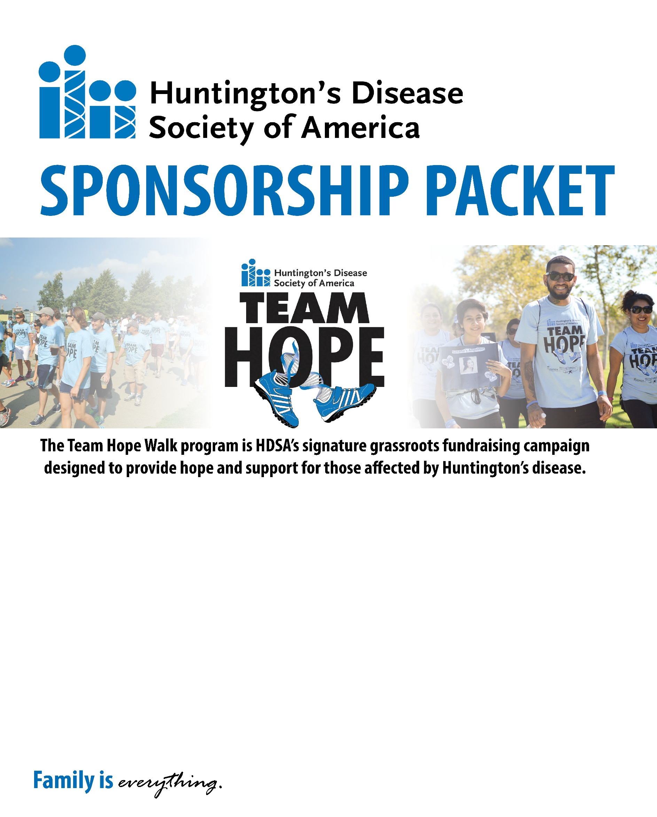
Spokane Area Team Hope Walk
May 20, 2017

WITH Performance
1950 Bellerive Ln. #106-A
Coeur d’Alene, ID 83814

www.hdsa.org/thwspokane

Dear Friends of HD Families,
The Huntington’s Disease Society of America (HDSA) is excited to announce the Spokane, WA Team Hope Walk to be held Saturday, May 20, 2017 at WITH Performance in Coeur d’Alene, ID. Team Hope Walk events represent the largest local opportunity for members of the HD community to come together with friends, family members, neighbors and the community at large to raise necessary awareness and funds to support HDSA. We sincerely hope that you will join us this May.
Huntington’s disease (HD) is a fatal genetic disorder that causes the progressive breakdown of nerve cells in the brain. It deteriorates a person’s physical and mental abilities during their prime working years and has no cure.
Every child of a parent with HD has a 50/50 chance of carrying the faulty gene that causes HD. Today, there are 30,000 symptomatic Americans and more than 200,000 at-risk of inheriting the disease. Many describe the symptoms of HD as having ALS, Parkinson’s and Alzheimer’s – simultaneously.
A local Team Hope Walk sponsorship at any level is an excellent opportunity for you to support a great cause and to take advantage of a wonderful marketing opportunity. Since their inception, Team Hope Walks have raised more than $9 million and involved tens of thousands of participants from local communities across America. As a local sponsor, you will be increasing your brand recognition and visibility, demonstrating your commitment to the local community your employees and customers live and work in.
Proceeds from Team Hope support the mission and programs of HDSA, the premier nonprofit organization dedicated to improving the lives of everyone affected by Huntington’s disease. From community services and education to advocacy and research, HDSA is the world’s leader in providing help for today, hope for tomorrow for people with Huntington’s disease and their families. In the battle against Huntington’s disease no one fights alone. At HDSA, family is everything.
This cause is extremely important to so many members of our community. Your sponsorship of the Team Hope Walk program will be greatly appreciated and will make a huge difference to the thousands of families who are living with HD. We are requesting all types of support including sponsorship, in-kind goods, and corporate teams to participate in the walk and volunteers. To learn more about Huntington’s disease and HDSA, please visit www.hdsa.org, and our Team Hope webpage at www.hdsa.org/teamhope.
Enclosed you will find a packet that outlines the sponsorship opportunities in detail. Please contact me directly if you have questions or need additional information. Thank you for your consideration, and we hope to see you at the Team Hope Walk on May 20, 2017.

Zane Graser
(425) 354-5610
zegman21@gmail.com

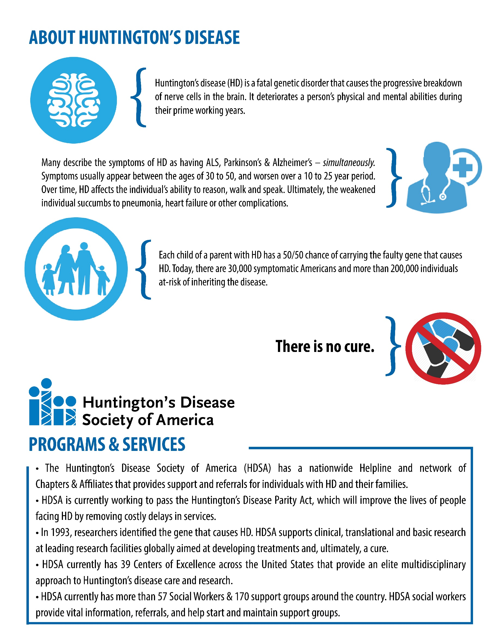
Spokane, WA Team Hope Walk
May 20, 2017
WITH Performance – 1950 Bellerive Ln. #106-A Coeur d’Alene, ID 83814

Presenting Sponsor - $5,000
- Name and Logo prominently featured on event website and all event email blasts
- Logo as Presenting Sponsor on event Banner
- Logo printed on walk route signage
- Logo included on event poster and information sheet
- Logo featured on back of participant t-shirts
- Premier Vendor/Exhibit space at event to distribute product and promotional materials
- Recognition in HDSA’s 2016 Year in Review Magazine
- Sponsor highlighted in all pre- and post-event publicity

Gold Sponsor - $2,500
- Name and Logo featured on event website and all event email blasts
- Logo printed on walk route signage
- Logo included on event poster and information sheet
- Logo featured on back of participant t-shirts
- Vendor/Exhibit space at event to distribute product and promotional materials
- Sponsor mentioned in all pre- and post-event publicity

Silver Sponsor - $1,000
- Logo printed on walk route signage
- Logo included on event poster and information sheet
- Logo featured on back of participant t-shirts
- Vendor/Exhibit space at event to distribute product and promotional materials

Bronze Sponsor - $500
- Logo included on event poster and information sheet
- Logo featured on back of participant t-shirts
- Vendor/Exhibit space at event to distribute product and promotional materials

Event Sponsor - $250
- Vendor/Exhibit space at event to distribute product and promotional materials
- Logo featured on back of participant t-shirts

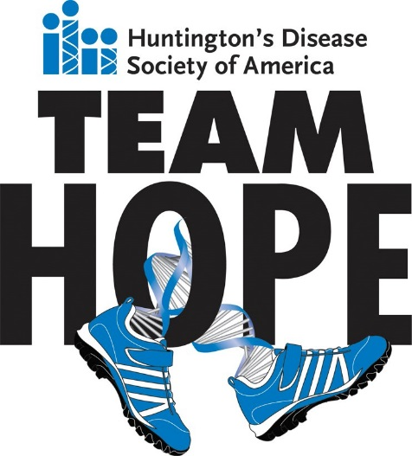
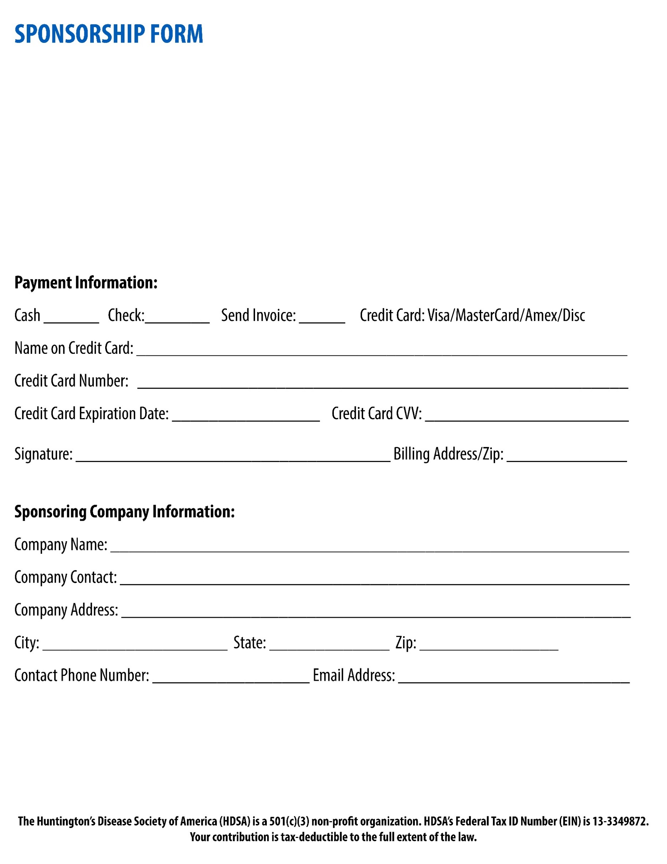
SUBMIT COMPLETED FORM TO:
HDSA
Attn: Spokane THW
505 Eighth Avenue, Suite 902
New York, NY 10018
Select Sponsorship Level:
 PRESENTING SPONSOR $5,000
 GOLD SPONSOR $2,500
 SILVER SPONSOR $1,000
 BRONZE SPONSOR $500
 EVENT SPONSOR $250
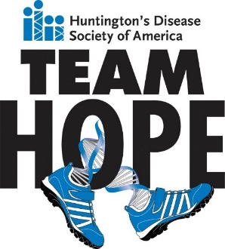
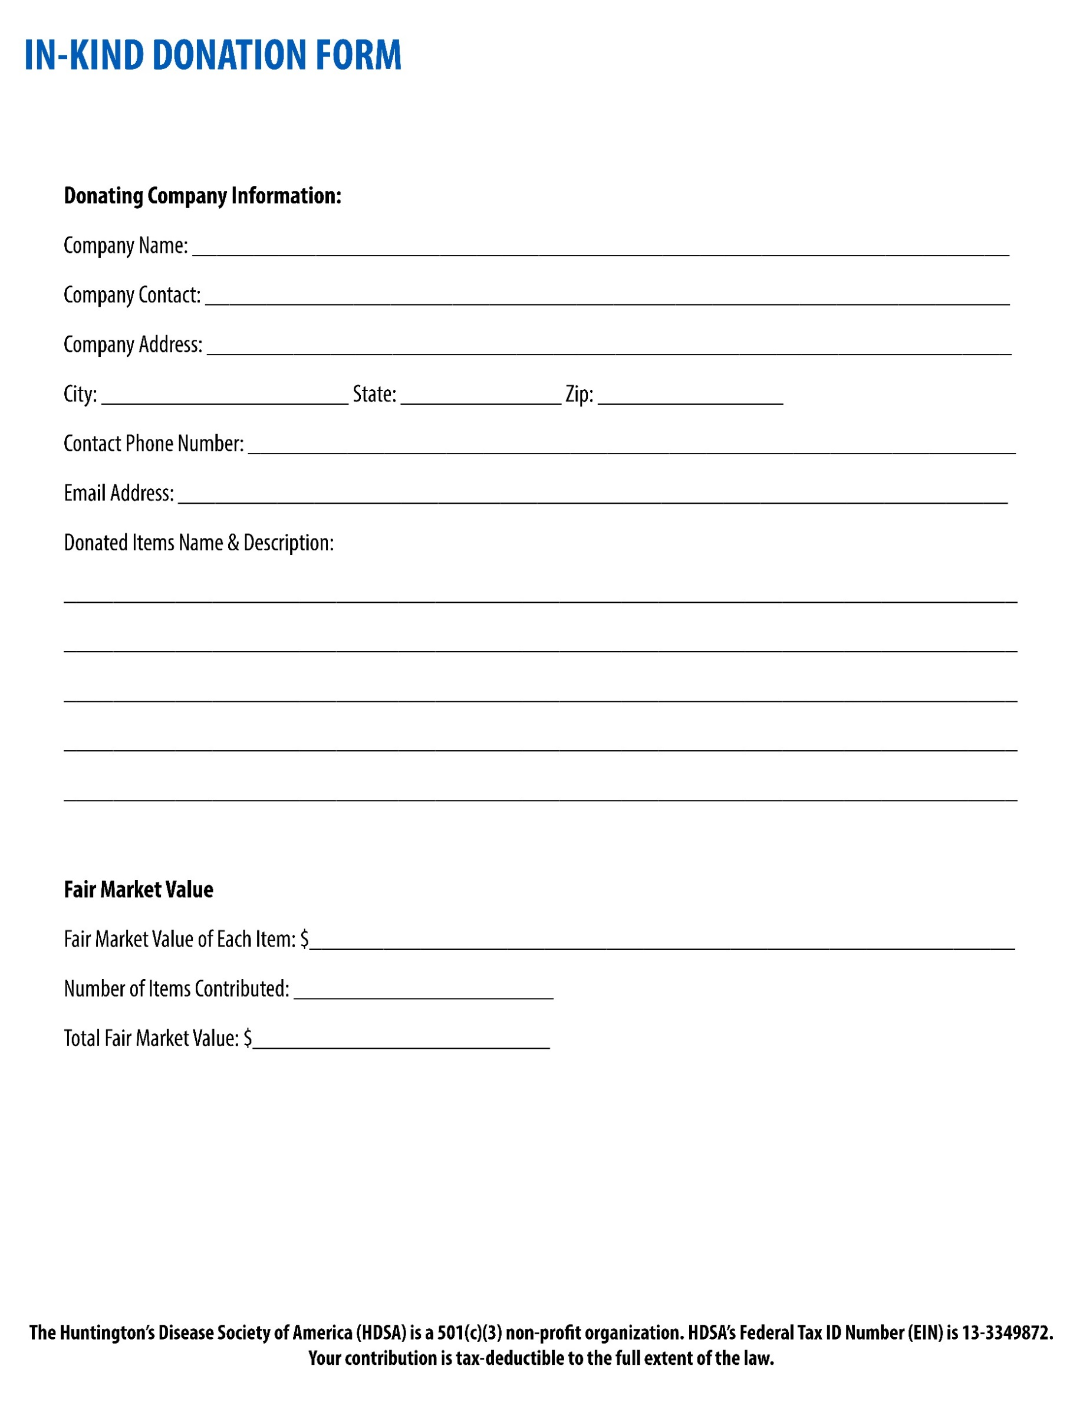
SUBMIT COMPLETED FORM TO:
HDSA
Attn: Spokane THW
505 Eighth Avenue, Suite 902
New York, NY 10018

