[DATE]

BUSINESS NAME
Attn. NAME
ADDRESS
CITY, STATE ZIP CODE

Dear NAME,

I am member of the Be The Match® Chapter on campus at [INSERT SCHOOL].

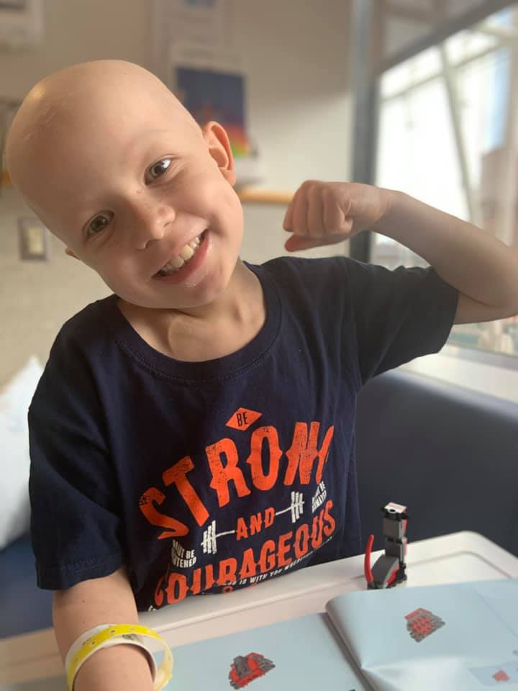
For people with life-threatening blood cancers—like leukemia—or other blood disorders like sickle cell, a cure exists. Be The Match connects patients with a matching donor for a life-saving blood stem cell transplant, providing support every step along the transplant journey.

While a blood stem cell transplant can provide a second chance at life for thousands of patients each year, the financial cost of the treatment journey can be a devastating hardship—even with insurance. These financial barriers can prevent patients from moving forward to transplant. But we are doing something about it.

Your dollars provide cures
Together, with students across the country we have a goal of raising $50,000 this school year. We’re raising critical funds to help remove financial barriers for patient families, like Zeke’s, as they journey to, and through, a marrow transplant.

Can I count on you to support our efforts with a contribution of any amount? Every dollar counts to help save more lives. Be The Match Foundation® is a nonprofit organization and your contribution is tax-deductible (EIN # 41-1704734). To learn more, please visit BeTheMatch.org.
Zeke, blood stem cell transplant recipient

Together, we’ll create more possibilities for patients like Zeke.

Gratefully,

[NAME]
Be The Match Campus Chapter member
[YOUR COLLEGE/UNIVERSITY NAME]

