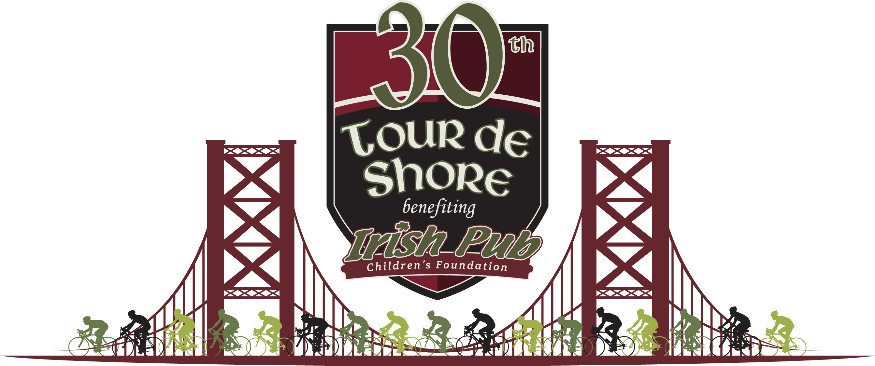

Dear family and friends,

On Sunday July 30th, I will be joining over 2,500 other cyclists to ride in the 30th Annual Irish Pub Tour de Shore. This exciting 65-mile bike ride from the Irish Pub at 20th & Walnut in Philadelphia to the Irish Pub in Atlantic City is the flagship event of the Irish Pub Children’s Foundation (IPCF).

The Irish Pub Children’s Foundation is a 501(c)(3) non-profit committed to improving the lives in the community we live. We do this in three ways: by supporting first responders and their families who are killed or severely injured in the line of duty, improving relationships between law enforcement and the community they serve and encouraging our children through education and recreation.

Throughout their history the Irish Pub Children’s Foundation has raised awareness as well as over $6 million for various children’s beneficiaries. Last year the Irish Pub Tour de Shore raised $1,022,000! The IPCF nets over 80% of all funds raised- putting the IPCF in the top tier of all non- profit organizations in the country.

With your help I can reach my personal goal of $_____ and contribute to this worthy cause. [Add a sentence about why you ride.]

Any amount that you are able to donate can make a difference and all donations are tax deductible. Please visit my Personal Fundraising Page at [INSERT URL] to make a donation and www.irishpubphilly.com for more information on the event. If you would prefer to mail a check, you can send it to:

Irish Pub Children’s Foundation
2007 Walnut Street
Philadelphia, PA 19103
*Just be sure to make a note somewhere on the check that you are donating the money to me!

We hope to make this year our most successful one yet and raise even more for the children of the Greater Philadelphia and South Jersey Region.

Regards,

[Insert name here]

