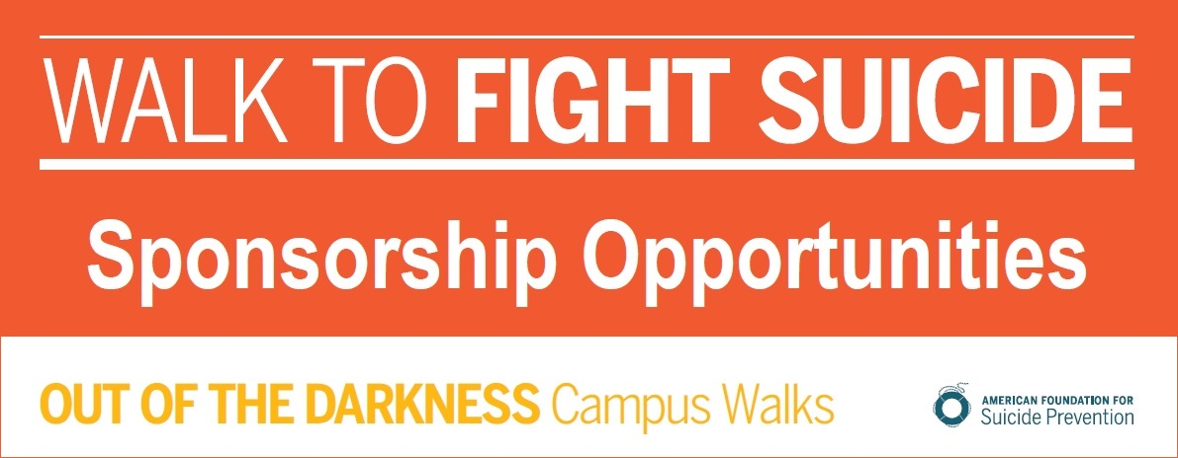

2018 University of Louisville Campus Walk

afsp.org/WalkURL
April 8, 2018
University of Louisville Belknap Campus
AFSP.ORG
http://tinyurl.com/UofLOOTDCWalk

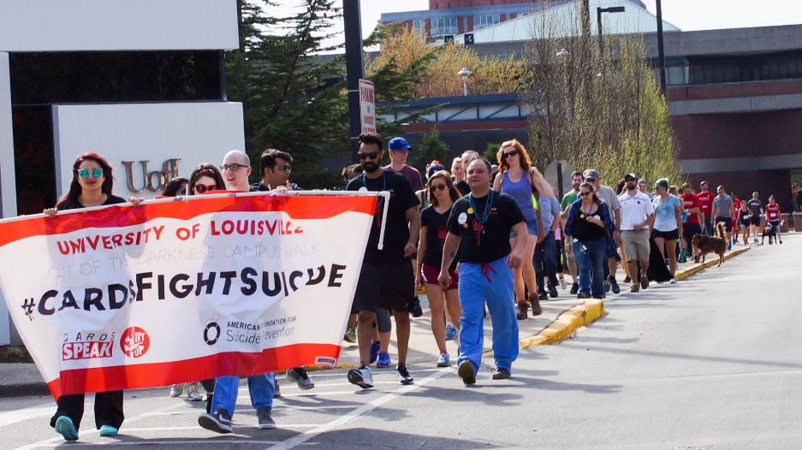

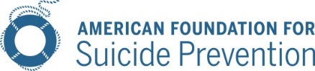

Dear Friend and Community Leaders,
You can be an everyday hero in the fight against suicide.
Partner with us as an event sponsor for the 2018 Out of the Darkness Campus Walk, taking place on April 8, 2018 at the University of Louisville, Belknap Campus.
Why support the University of Louisville Out of the Darkness Campus Walk?
Suicide is a leading cause of death – and it is preventable. With your support, we’ll be one step closer to achieving our bold goal of reducing the suicide rate 20% by 2025.
Build your brand’s goodwill by supporting a cause everyone can get behind.
Our walkers are passionate supporters of the cause, with 78% of online registrants indicating a personal investment in suicide prevention. And goodwill goes a long way: 91% of global consumers are likely to switch brands to one associated with a good cause, given comparable price and quality.
Not only are consumers making purchase decisions with purpose top of mind, they are also buying and advocating for purposeful brands. 72% of consumers would recommend a brand that supports a good cause over one that doesn’t.

Sponsor the University of Louisville Campus Walk and show our community that you’re a voice for suicide prevention.

The American Foundation for Suicide Prevention leads the fight against suicide.
Funds raised from The Out of the Darkness Walks allow us to fund research, create educational programs, advocate for public policy, and support survivors of suicide loss.
I look forward to discussing our 2018 sponsorship opportunities and benefits with you in more detail
For more information, please contact:
Tracie Meyer, Walk Chairperson
University of Louisville
Out of the Darkness Campus Walk
502-852-5787
tracie.meyer@louisville.edu

Out of The Darkness University of Louisville CAMPUS Walk
Sponsorship Levels

Cardinal RED Level Sponsor | Donate $100
Benefits Include:
The opportunity to support the nation’s leading non-profit organization dedicated to understanding and preventing suicide through research, education and advocacy, and to reaching out to people with mental disorders and those impacted by suicide.
A tax-deductible donation & donation receipt
Social media shout out on the 2017 University of Louisville Campus Walk sites.

Bronze Level Sponsor | Donate $250
Benefits Include:
The opportunity to support the nation’s leading non-profit organization dedicated to understanding and preventing suicide through research, education and advocacy, and to reaching out to people with mental disorders and those impacted by suicide.
A tax-deductible donation & donation receipt
Social media shout out on the 2017 University of Louisville Campus Walk sites
Your logo on the 2018 University of Louisville Campus Walk website that links to your company’s website.

Silver Level Sponsor | Donate $500
Benefits Include:
Bronze Level Sponsorship Benefits listed above.
Your logo on the back of walker t-shirts. University of Louisville Campus Walk has 250 Walkers!
2 complimentary University of Louisville Campus Walk t-shirts
Sign at event listing your company as an event sponsor.

Gold Level Sponsor | Donate $1000
Benefits Include:
Bronze & Silver Level Sponsorship Benefits listed above.
Your company recognized in announcements at event.
4 complimentary University of Louisville Campus Walk t-shirts.
Sign at event listing your company as an event sponsor.

Platinum Level Sponsor | Donate $2500
Benefits Include:
Bronze, Silver, & Gold Level Sponsorship Benefits listed above.
10 complimentary University of Louisville Campus Walk t-shirts.
One onsite presentation at your company’s site about AFSP.
Tent provided by you for your company’s walk team at the event.
Sign at event listing your company as an event sponsor.

Out of The Darkness university of louisville CAMPUS Walk
2018 Sponsorship Agreement

Please Print
Name/Company:

Mailing Address:
City: State: Zip:

Contact Name:

Phone: Email:
Company Website Address:
Is this a new or returning sponsor? ____________ Please select sponsorship options:
Cash Sponsorship:  Platinum Level Sponsor | Donate $2500  Gold Level Sponsor | Donate $1000  Silver Level Sponsor | Donate $500  Bronze Level Sponsor | Donate $250  Cardinal RED Level Sponsor | Donate $100 | OR | In-Kind Sponsorship:  Product:  OR Service:  Fair market Value* (product or service): $  Value Determined by:  *min
Additional Options:
Call me, I am interested in forming a team for the walk
Unable to sponsor, but please accept this donation$
Referred by (if someone referred you to us, please let us know):
We authorize The American Foundation for Suicide Prevention to include our corporate name and logo on all “Out of the Darkness” materials consistent with our sponsorship selection and publication dates.

Authorized Signature: Date:
Donation Via:
Enclosed Check Invoice Required to Process Payment
Credit Card: AMEX Mastercard Visa Discover
CARD NO.
EXP. DATE: CODE: BILLING ZIP:
Card Holder Name (if different than Contact Person Name):
Completed & Signed Agreement with Logo Due by March 9, 2018
Logo Specifications: T-shirt: Vector file (EPS, PS, PDF) format to ensure logo integrity. Website: Stacked logos appear best (max width is 80px) and we accept vector files and/or image files (.jpeg, .png).
Please scan and email or mail this agreement, logo, & Website link to:
Email: walks@afsp.org | Mail: AFSP, ATTN: OOTD WALKS, 120 Wall Street, 29th FL, New York, NY 10005
Thank You for Your Generous Support of the American Foundation for Suicide Prevention!

2013 Cone Communications/Echo Global CSR Study
Edelman goodpurpose® 2012

