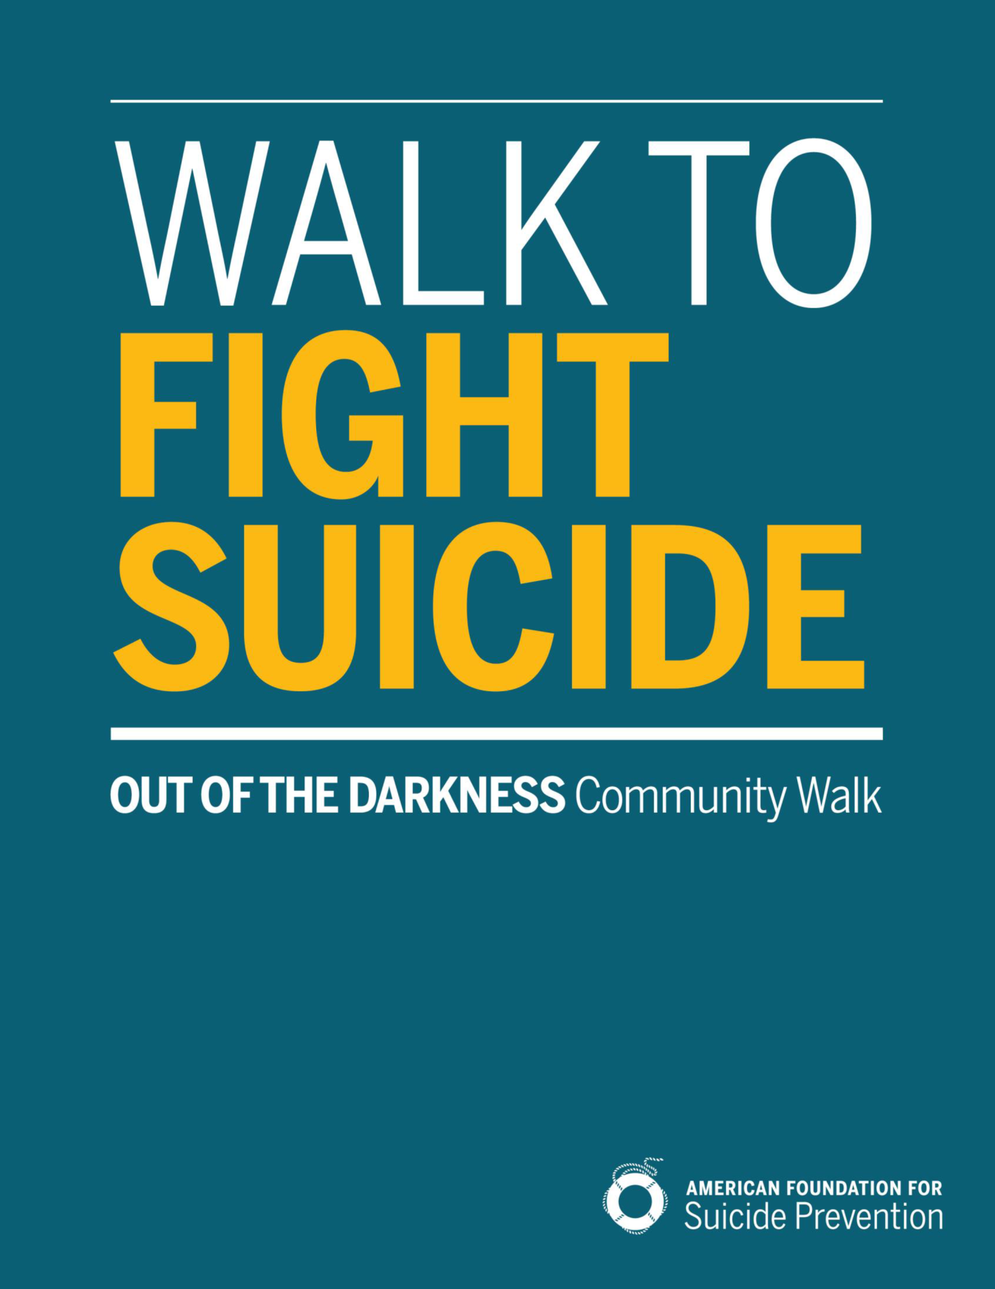
afsp.org/Norfolk

2017 Norfolk Walk
Sponsorship Opportunities
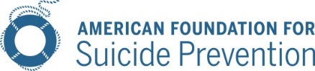
June 21, 2017

Dear Friend and Community Leader,
You can be an everyday hero in the fight against suicide.
Partner with us as an event sponsor for the 2017 Norfolk Out of the Darkness Walk, taking place on October 14, 2017at the MacArthur Center Green, 300 Monticello Avenue.
Why support the Norfolk and/or all four Hampton Roads Out of the Darkness Walk?
Suicide is a leading cause of death – and it is preventable. With your support, we will be one step closer to achieving our bold goal of reducing the suicide rate 20% by 2025. AFSP has been working in our community for more than a decade. The vast majority of suicide prevention programs that are presented in Hampton Roads each year are either sponsored directly or indirectly by AFSP to prevent Your contribution will make an immediate impact locally, as well as provide support to the larger effort within our nation to fund the large-scale efforts, such as the necessary research required to meet our bold goal.
Build your brand’s goodwill by supporting a cause everyone can get behind.
Our walkers are passionate supporters of the cause, with 78% of online registrants indicating a personal investment in suicide prevention. And goodwill goes a long way: 91% of global consumers are likely to switch brands to one associated with a good cause, given comparable price and quality.
Not only are consumers making purchase decisions with purpose top of mind, they are also buying and advocating for purposeful brands. 72% of consumers would recommend a brand that supports a good cause over one that doesn’t.

Sponsor the Norfolk Out of the Darkness Walk and show our community that you’re a voice for suicide prevention.

The American Foundation for Suicide Prevention leads the fight against suicide.
Funds raised from The Out of the Darkness Walks allow us to fund research, create educational programs, advocate for public policy, and support survivors of suicide loss.
I, and the rest of our Norfolk Out of the Darkness Walk Committee, sincerely appreciate your support.
Signed,
Eric Peterson
Norfolk Walk Chairperson
For more information, please contact:
John Laudenslager, Sponsorship Coordinator
jlauden@cox.net
757-679-5186

Out of The Darkness Norfolk Community Walk
NOrfolk lifesaver Sponsorship Levels

NORFOLK BASIC LIFESAVER SPONSOR | Donate $250
Benefits Include:
The opportunity to support the nation’s leading non-profit organization dedicated to understanding and preventing suicide through research, education and advocacy, and to reaching out to people with mental disorders and those impacted by suicide.
A tax deductible donation & donation receipt
Company/Logo name listed on the walk website

NORFOLK BRONZE LIFESAVER SPONSOR | Donate $500
Benefits Include:
Basic Level Sponsorship Benefits listed above
Sponsor recognition in electronic communication (1 minimum)
Company/Logo name listed on the walk website and t-shirt
Sponsor recognition on Chapter Facebook page(s)

NORFOLK SILVER LIFESAVER SPONSOR | Donate $1000
Benefits Include:
Basic & Bronze Level Sponsorship Benefits listed above
Sponsor recognition in electronic communications (2 minimum)
Opportunity to include promotional item in walker gift bags
5 complimentary 2017 Out of the Darkness Norfolk Community Walk t-shirts
NORFOLK GOLD LIFESAVER SPONSOR | Donate $2500
Benefits Include:
Basic, Bronze & Silver Level Sponsorship Benefits listed above
Your company recognized in announcements at event.
10 complimentary 2017 Out of the Darkness Norfolk Community Walk T-shirts
Company Logo/name on sponsor signage or banner at walk venue
AFSP Lunch and Learn for your employees

NORFOLK PLATINUM LIFESAVER SPONSOR | Donate $5000
Benefits Include:
Basic, Bronze, Silver, & Gold Level Sponsorship Benefits listed above
15 complimentary 2017 Out of the Darkness Norfolk Community Walk t-shirts
Sponsor tent/tabling opportunity at walk(s)-may provide own branded tent
Acknowledgement in radio, print, digital ads (as allowed)

NORFOLK PRESENTING SPONSOR | Donate $10,000
Benefits Include:
All Level Sponsorships Benefits listed above
Norfolk Walk “Presented by” your company
Your logo on all four Hampton Roads Walk T-shirts and Websites
20 complimentary 2017 Out of the Darkness Community Walk t-shirts

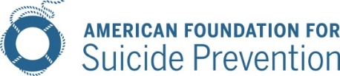
2017 Sponsorship Agreement: Norfolk Out of Darkness Community Walk

Name/Company:

Mailing Address:
City: State: Zip:

Contact Name:

Phone: Email:
Company Website Address:
Please select one of two sponsorship options:
Cash Sponsorship:  Presenting Level Sponsor | Donate $10,000  Platinum Level Sponsor | Donate $5,000  Gold Level Sponsor | Donate $2,500  Silver Level Sponsor | Donate $1,000  Bronze Level Sponsor | Donate $500  Basic Level Sponsor | Donate $250 | OR | In-Kind Sponsorship:  Product:  OR Service:  Fair market Value* (product or service): $  Value Determined by:  *min

Additional Options:
Call me, I am interested in sponsoring additional walks in Hampton Roads or statewide
Call me, I am interested in forming a team for the walk
We authorize The American Foundation for Suicide Prevention to include our corporate name and logo on all “Out of the Darkness” materials consistent with our sponsorship selection and publication dates.

Authorized Signature: Date:
Donation Via:
Enclosed Check Invoice Required to Process Payment
Credit Card: AMEX Mastercard Visa Discover
CARD NO.
EXP. DATE: CODE: BILLING ZIP:
Card Holder Name (if different than Contact Person Name):
Completed & Signed Agreement with Logo Due by September 14, 2017
Logo Specifications: T-shirt: Vector file (EPS, PS, PDF) format to ensure logo integrity. Website: Stacked logos appear best (max width is 80px) and we accept vector files and/or image files (.jpeg, .png).
Please scan and email or mail this agreement, logo, & Website link to: anneleighfsp@gmail.com
Email: walks@afsp.org | Mail: AFSP, ATTN: OOTD WALKS, 120 Wall Street, 29th FL, New York, NY 10005

2013 Cone Communications/Echo Global CSR Study
Edelman goodpurpose® 2012

