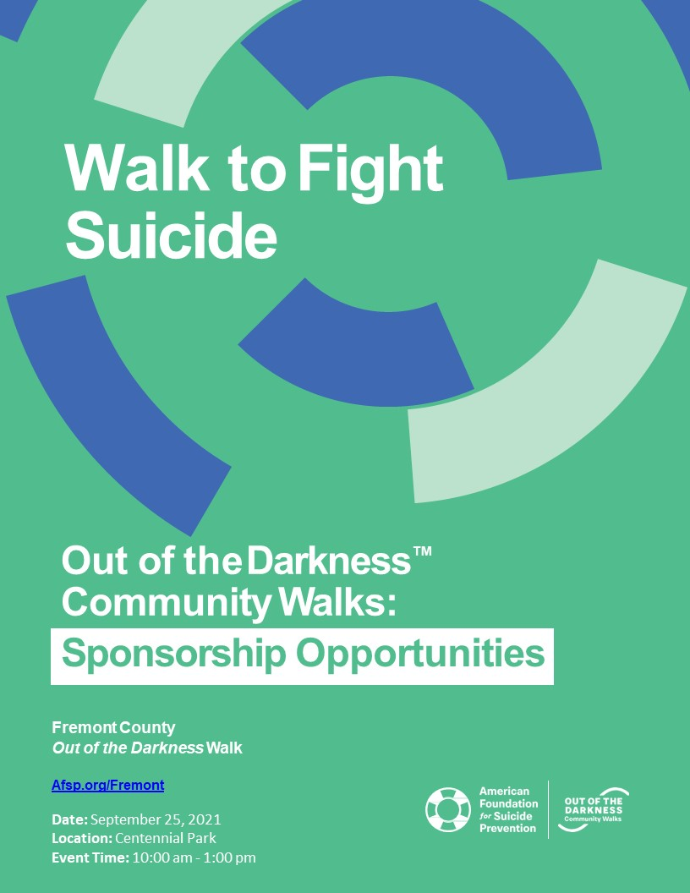

Dear Friend and Community Leader,
You can be an everyday hero in the fight against suicide.
Partner with us as an event sponsor for the 2021 Fremont County Out of the Darkness Walk, taking place on September 25th, 2021 at Centennial Park, 221 Griffin Ave. Canon City, Colorado (also known as Duck Park) as part of the 2021 Fremont County Walk. Why support the Fremont County Out of the Darkness Walk?
Suicide is a leading cause of death – and it is preventable. With your support, we’ll be one step closer to achieving our bold goal of reducing the suicide rate 20% by 2025.
Build your brand’s goodwill by supporting a cause everyone can get behind.
Our supporters are passionate about the cause, with 78% of online registrants indicating a personal investment in suicide prevention. And goodwill goes a long way: 91% of global consumers are likely to switch brands to one associated with a good cause, given comparable price and quality. .
Not only are consumers making purchase decisions with purpose top of mind, they are also buying and advocating for purposeful brands. 72% of consumers would recommend a brand that supports a good cause over one that doesn’t.

Sponsor the 2021 Fremont County Walk and show our community that you’re a voice for suicide prevention.

The American Foundation for Suicide Prevention leads the fight against suicide.
Funds raised from The Out of the Darkness Walks allow us to fund research, create educational programs, advocate for public policy, and support survivors of suicide loss.
I look forward to discussing our 2021 sponsorship opportunities and benefits with you in more detail.
For more information, please contact:
Jessica Cobler, Fremont County OOTD Walk Chair Brenda McDermott, OOTD Walk Co-Chair
AFSP Colorado Chapter AFSP Colorado Chapter
Fremont County Out of the Darkness Walk Fremont County Out of the Darkness Walk
(719) 671-2676 719-369-2968
jessicarc01@hotmail.com jimbrendamcd@msn.com
Together to Save Lives and Bring Hope to Those Affected by Suicide!
Together to Honor a Loved One!
Together to Fight Suicide!

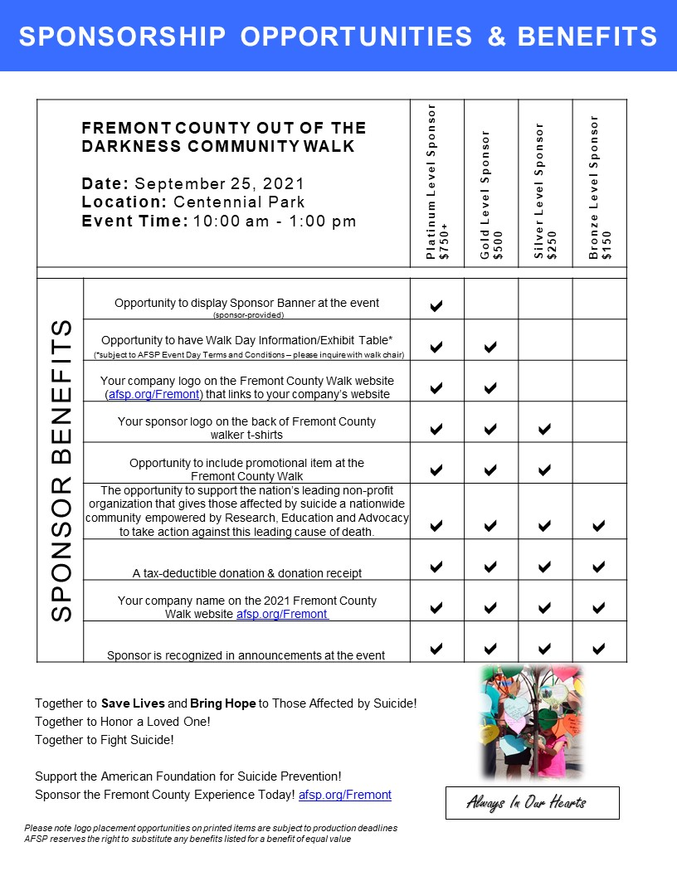

FREMONT COUNTY Out of The Darkness WALK
2021 Sponsorship Agreement
(9.25.21 CENTENNIAL PARK)

Please Print
Name/Company:

Mailing Address:
City: State: Zip:

Contact Name:

Phone: Email:
Company Website Address:
Please select one of two sponsorship options:
Cash Sponsorship:  £ Platinum Level Sponsor | Donate $750+  £ Gold Level Sponsor | Donate $500  £ Silver Level Sponsor | Donate $250  £ Bronze Level Sponsor | Donate $150 | OR | In-Kind Sponsorship: (to help save costs for AFSP)  Product:  OR Service:  Fair market Value* (product or service): $  Value Determined by:  *Value must be greater than or equal to minimum sponsor level cash amount to qualify for sponsor benefits
Additional Options:
£ Call me, I am interested in forming a team for the event
£ Unable to sponsor, but please accept this donation $
£ Referred by (if someone referred you to us, please let us know):
We authorize The American Foundation for Suicide Prevention to include our corporate name and logo on all “Out of the Darkness” materials consistent with our sponsorship selection and publication dates. (*Event Day Information/Exhibit Table subject to AFSP Event Day Terms and Conditions – please inquire with event chair)

Authorized Signature: Date:
Method of Payment:
£ Check Enclosed (made payable to AFSP w/ memo: Fremont County)
£ Call me to process payment via phone
Credit Card: £ AMEX £ Visa £ Mastercard £ Discover
CARD NO.
EXP. DATE: CVV: BILLING ZIP:
Card Holder Name (if different than Contact Person Name):
£ Invoice Required to Process Payment
Completed & Signed Agreement with Logo Due by August 6, 2021
Logo Specifications (where applicable): T-shirt: Vector file (EPS, PS, PDF) format to ensure logo integrity. Website: Stacked logos appear best (max width is 80px) and we accept vector files and/or image files (jpeg, png). If high-resolution (vector or image) logo file is not provided, company name will appear on shirts and/or website as text, only.
Please sign and return this agreement, logo, & payment to:
Email: jessicarc01@hotmail.com | P.O. Box 1, Coal Creek CO 81221
Thank You for Your Generous Support of the American Foundation for Suicide Prevention!

2013 Cone Communications/Echo Global CSR Study
Edelman goodpurpose® 2012

