PINTS For Prevention

ConFLUX BrEWing COmpany
Tuesday, June 4th
5 – 7 pm
25 cents from every pint is donated to the Missoula Out of the Darkness Walk
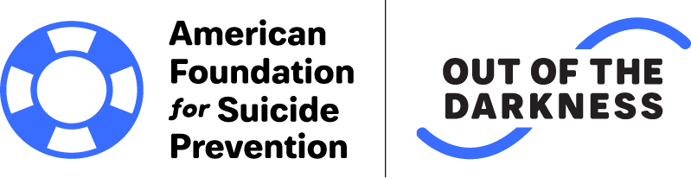
Join us for Pint Night as we fight to #stopsuicide
We will have a table of information regarding AFSP and our mission to save lives and bring hope to those affected by suicide. $.25 of each pint sold between 5PM and 7PM will go towards the Missoula Out of the Darkness Walk fundraising goal of $59,000.

